**DAILY ONLINE ACTIVITIES SUMMARY**

|  |  |  |  |  |  |  |  |
| --- | --- | --- | --- | --- | --- | --- | --- |
| **Date:** | **8/06/2020** | | | | **Name:** | **Samrin Banu** | |
| **Sem & Sec** | **8th B** | | | | **USN:** | **4AL16C082** | |
| Online Test Summary | | | | | | | |
| **Subject** | | **SMS** | | | | | |
| **Max. Marks** | | **60** | | **Score** | | **60** | |
| Certification Course Summary | | | | | | | |
| **Course** | **GUVI** | | | | | | |
| **Certificate Provider** | | | **Python** | **Duration** | | | **26 hrs** |
| Coding Challenges | | | | | | | |
| **Problem Statement:** 1) Python Program to Transpose a Matrix | | | | | | | |
| **Status: Solved** | | | | | | | |
| **Uploaded the report in Github** | | | | **YES** | | | |
| **If yes Repository name** | | | | **Samrinbanu** | | | |
| **Uploaded the report in slack** | | | | **YES** | | | |

Online test detail:

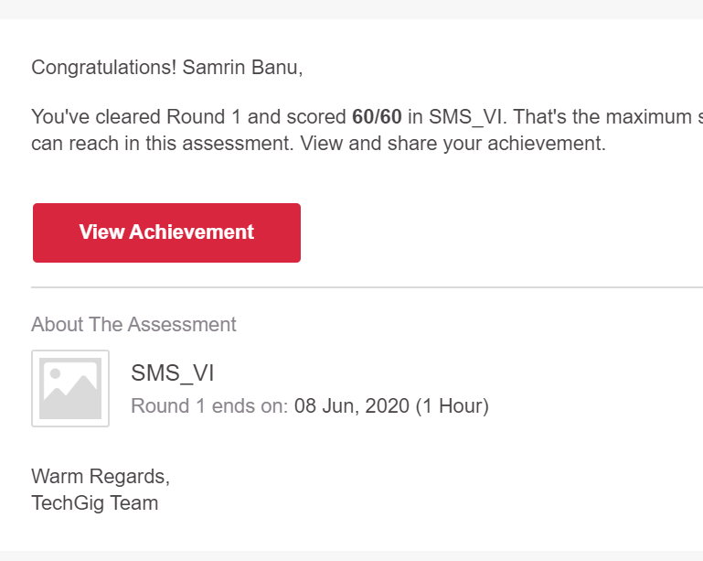

**Certification Course Details:**

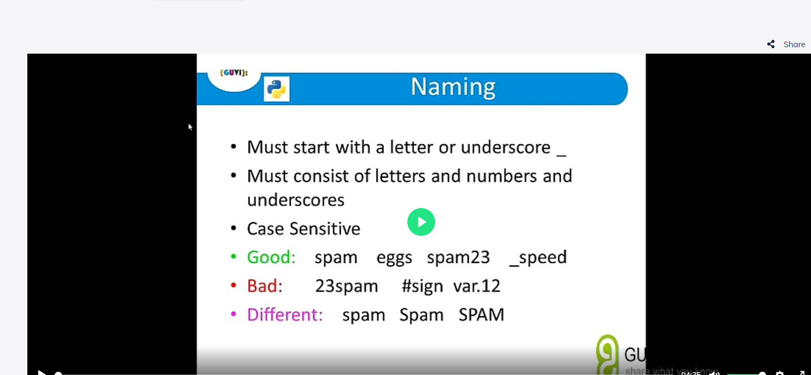

# CODE:

Program no:1

# Program to transpose a matrix using a nested loop

X = [[12,7],

[4 ,5],

[3 ,8]]

result = [[0,0,0],

[0,0,0]]

# iterate through rows

for i in range(len(X)):

# iterate through columns

for j in range(len(X[0])):

result[j][i] = X[i][j]

for r in result:

print(r)